ONLINE COURIER MANAGEMENT SYSTEM
Software Requirements Specification

Version 1.0



Group Id: F230278514
Supervisor Name: Dr. Nida Anwar

Revision History
Date (dd/mm/yyyy) | Version | Description | Author
04/12/2023 | 1.0
 |  | as OCMS will be a valuable tool for businesses that rely on efficient courier services. It will help businesses improve their operations, reduce costs, and improve customer service. If you are considering implementing an OCMS for your business, it is important to choose a system that is user-friendly, secure, and customizable to your specific needs. | MC220202421  Akasha Rauf

Table of Contents

- Scope (of the project)
- Functional Requirements Non Functional requirements
- Use Case Diagram
- Usage Scenarios
- Adopted Methodology
- Work Plan (Use MS Project to create Schedule/Work Plan)

SRS Document

Scope of Project:

An Online Courier Management System (OCMS) is a software application that enables businesses to manage their courier services efficiently. It allows businesses to track their shipments, manage their inventory, and automate their order fulfillment processes. The present application named as OCMS will enable businesses to track their shipments in real-time. This means that monitoring and delivering tracking of the shipments can easily be done through this application. This application will highly be beneficial in the realm of E-commerce businesses.
To manage inventory in any business is an essential and time taking activity, the present application named as OCMS will allow businesses to manage their inventory efficiently. This means that businesses can keep track of their stock levels and ensure that they have enough products to meet customer demand. This can help businesses to avoid stock outs and overstocking, which can be costly and time-consuming.
The present application named as OCMS will also automate the order fulfillment process. This means that businesses can automatically generate shipping labels, pack orders, and schedule pickups. This can save businesses time and reduce the risk of errors. It can also help businesses to improve their customer service by providing customers with real-time tracking information.
The present study named as OCMS will help businesses to improve their operations by providing them with valuable data and insights. For example, businesses can use the data provided by an OCMS to identify trends in customer demand, optimize their shipping routes, and reduce their transportation costs.
To sum up, the present application named as OCMS will be a valuable tool for businesses that rely on efficient courier services. It will help businesses improve their operations, reduce costs, and improve customer service. If you are considering implementing an OCMS for your business, it is important to choose a system that is user-friendly, secure, and customizable to your specific needs.

Functional and non Functional Requirements:

FUNCTIONAL REQUIRMENTS: -
- The admin must submit their system credentials to access the admin side after logging in.
- After logging in, the admin is redirected to the default dashboard which displays a summary of the system data.
- The admin can now submit information for new branches through the New Branch Page of the courier company.
- The Branches page displays and manages all courier company locations.
- The system admin can create new users for specific branches.
- The Branch Staff List Page displays and manages all system users across branches.
- The New Parcel Page is where system users can submit information about parcels, including
- details of the sender, destination, date, time, amount, recipient and all.
- The Parcel List Page is where parcels are listed and managed. It is the page where you can view and organize all your parcels in one place.
- The Parcel List Page is the page where the parcels are displayed and managed. It provides a list of all the parcels and allows users to perform various actions on them such as adding, editing, or deleting parcels.
- The Track Parcel Page displays the current location of the client's packages.
- The Report Page displays a printable list of courier transactions with clients.
NON-FUNCTIONAL REQUIREMENTS
Usability:
Usability of the software can be easy so that the user can use it easily without any difficulty
Maintainability:
Software should be built up in such a way that classification of errors and maintains of application becomes easy
Operating System:
Software should be able to run on all type of operating systems like Windows XP, Window 7 and others.
Some of the others are:
Accessibility
Security
Actors:
The system consists of two main modules as follows:
Admin
Customers
Tools: PHP, MySQL, VsCode, Google Chrome , Notepad++ etc.
Application Type: Web based Application
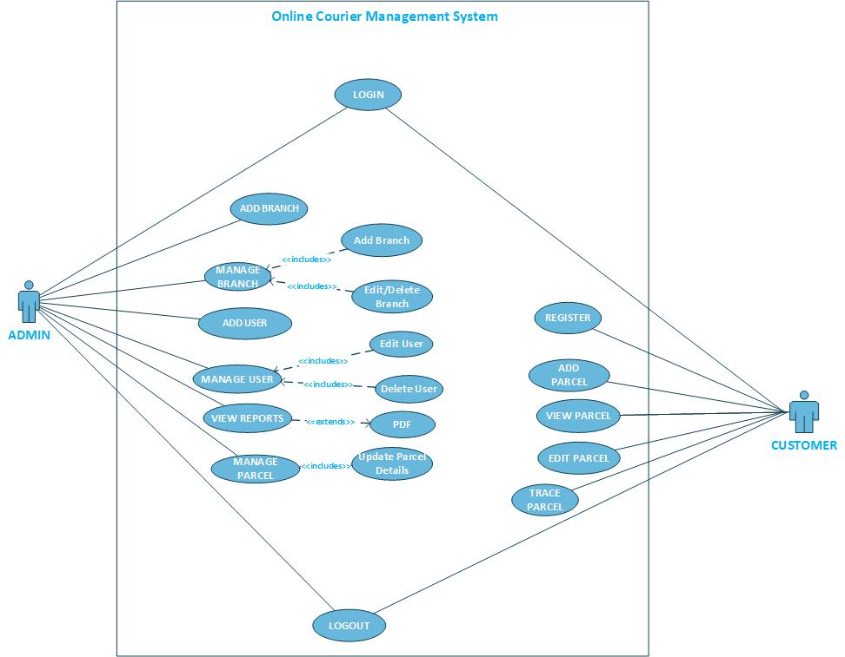
Use Case Diagram(s):

USAGE SCENARIOS:
REGISTER:

Use Case id | UC_1
Use Case title | REGISTER
Description | All customers who wants to use this system to send parcel or courier must have to register themselves on this website.
Pre-condition | Application interface must be available.
Action | - Open application interface of create account  - Fill the form of registration  - Click on “Register” button to get registered
Post Conditions | Customer successfully created in database.
Alternative Path: | Customer may not want to register this time
Exception: | If the customer entered invalid data in the form then the exception occurs “Fill mandatory Fields”
Authority | Customer
Author | Akasha Rauf (MC220202421)

LOGIN:

Use Case id | UC_2
Use Case title | LOGIN
Description | All stakeholders/Actors of the website must have to login to use some key features of this website.
Pre-condition | Actors must be registered with our website , Application interface must be available
Action | - Open application interface of login  - Enter user name and password  - Click on “Login” button
Post Conditions | Actors successfully login and able to further work
Alternative Path: | Actors may not want to login this time
Exception: | If the user entered invalid data in the form then the exception occurs “Invalid user name and password”
Authority | Customer, Admin
Author | Akasha Rauf (MC220202421)

ADD BRANCH:

Use Case id | UC_3
Use Case title | ADD BRANCH
Description | This use case allows admin of the system to maintain to add different branches of courier services in different cities
Pre-condition | Admin user of the system must be registered with our website and logged in.
Action | - Login as Admin  - Fill add branch form  - Click on “Add New Branch” button
Post Conditions | Branch successfully added in database and available to customers
Alternative Path: | -
Exception: | If the user entered invalid data in the form then the exception occurs “Please enter correct and valid data”
Authority | Admin
Author | Akasha Rauf (MC220202421)

ADD USER:

Use Case id | UC_4
Use Case title | ADD USER
Description | This use case allows admin of the system to add users which is later on be able to use this software.
Pre-condition | Admin user of the system must be registered with our website and logged in.
Action | - Login as Admin  - Fill add user form  - Click on “Add User” button
Post Conditions | Users successfully added and available on our website.
Alternative Path: | -
Exception: | If the user entered invalid data in the form then the exception occurs “Please enter correct and valid data”
Authority | Admin
Author | Akasha Rauf (MC220202421)

MANAGE USERS:

Use Case id | UC_5
Use Case title | MANAGE USERS
Description | This usecase allows admin user of the system to manage all Users registered on our website any time
Pre-condition | Application interface must be available. And system must be logged in as Admin
Action | - Open application interface of create account  - View manage_user.php page  - Select Particular user to manage  - Perform your desired actions(edit/delete)
Post Conditions | Updated information added in database.
Alternative Path: | Admin may not want to manage user this time
Exception: | If the user entered invalid data in the form then the exception occurs “Fill mandatory Fields”
Authority | Admin
Author | Akasha Rauf (MC220202421)

MANAGE BRANCHES:

Use Case id | UC_6
Use Case title | MANAGE BRANCHES
Description | This usecase allows admin user of the system to manage all branches available on our website any time
Pre-condition | Application interface must be available. And system must be logged in as Admin
Action | - Open application interface of create account  - View manage_branches.php page  - Select Particular branch to manage  - Perform your desired actions(edit/delete)
Post Conditions | Updated information of branch is added in database.
Alternative Path: | Admin may not want to manage branch this time
Exception: | If the user entered invalid data in the form then the exception occurs “Fill mandatory Fields”
Authority | Admin
Author | Akasha Rauf (MC220202421)

VIEW REPORTS:

Use Case id | UC_7
Use Case title | GENERATE REPORTS
Description | This use case is about generating/viewing different reports of our system
Pre-condition | Application interface must be available. And system must be logged in as Admin
Action | - Open application interface of create account  - Click on “View Reports” button  - Select Your desired report i.e monthly daily etc
Post Conditions | Reports generated successfully.
Alternative Path: | -
Exception: | If user is not admin this will not work
Authority | Admin
Author | Akasha Rauf (MC220202421)

MANAGE PARCEL:

Use Case id | UC_8
Use Case title | MANAGE PARCEL
Description | This usecase allows admin user of the system to manage all parcels and update status of parcels added by Customer.
Pre-condition | Application interface must be available. And system must be logged in as Admin
Action | - Open application interface of create account  - View manage_parcels.php page  - Select Particular Parcel to manage  - Perform your desired actions(Add status of the parcel)
Post Conditions | Status of parcel is Upated and added in database.
Alternative Path: | Admin may not want to manage parcel this time
Exception: | If invalid data entered in the form then the exception occurs “Fill mandatory Fields”
Authority | Admin
Author | Akasha Rauf (MC220202421)

ADD PARCEL:

Use Case id | UC_9
Use Case title | ADD PARCEL
Description | This use case is about adding parcel.
Pre-condition | Application interface must be available. And system must be logged in as Customer
Action | - Open application interface and open add parcel interface  - Add details of parcel i.e sender name , receiver name, parcel details, parcel weight in a web form  - Click on Add parcel
Post Conditions | Parcel submitted and available for customer to view status
Alternative Path: | -
Exception: | If invalid data entered in the form then the exception occurs “Fill mandatory Fields”
Authority | Customer
Author | Akasha Rauf (MC220202421)

VIEW PARCEL:

Use Case id | UC_10
Use Case title | VIEW PARCEL
Description | This use case allows customers to view the parcel which he has sent by using this system
Pre-condition | Application interface must be available
Action | - Open application interface select the view parcel tab.  - Details of all parcel are visible to customers
Post Conditions | Details of all parcel sent / received to be make visible to customers
Alternative Path: | Customer may not want to view parcel this time
Exception: | If customer is not logged in this use case does not work
Authority | Customer
Author | Akasha Rauf (MC220202421)

TRACK PARCEL:

Use Case id | UC_11
Use Case title | TRACK PARCEL
Description | This use case allows customers to view the status of the parcel which he has sent by using this system
Pre-condition | Application interface must be available
Action | - Open application interface select the view parcel tab.  - Select your desired parcel  - Current status of the parcel is visible to customer
Post Conditions | Status of all parcel sent / received to be make visible to customers
Alternative Path: | -
Exception: | If customer is not logged in this use case does not work
Authority | Customer
Author | Akasha Rauf (MC220202421)

LOGOUT

Use Case id | UC_12
Use Case title | LOGOUT
Description | This use case allows all the actors of the system to logout from website.
Pre-condition | The application interface must be available and any of the actor must be Logged in.
Action | - Open application interface.  - Click on Logout Button.
Post Conditions | Session is destroyed and actor will be logout from system.
Alternative Path: | Force close website.
Exception: | If session is empty than this feature is not available.
Authority | Admin,Customers
Author | Akasha Rauf (MC220202421)

Adopted Methodology

Different methodologies and models are used by the people according to their work and planning. We will use “Vu process model” It is combination of two models Water Fall and Spiral methodologies.

Water fall methodology:

The water fall methodology consists on cycle of analysis, design, coding, testing, and maintenance. The simplest version is called "waterfall" methodology.

- The systems goals, services and limits are described by consulting the whole system with users
- The requirements are grouped into hardware and software systems. It gives overall design of the system.
- After installation system is used practically. The system than checks errors correct them and improve them

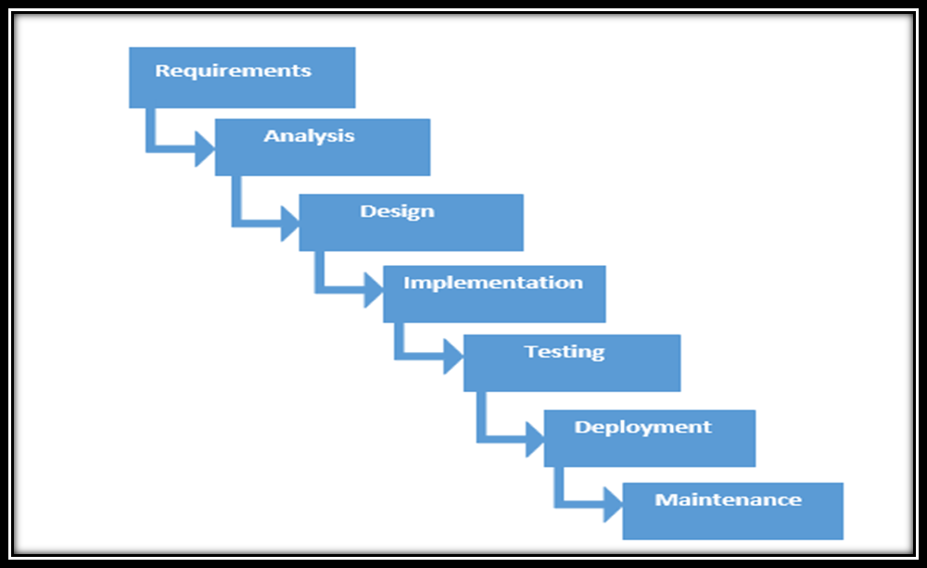

Spiral methodology:

- To eliminate the risk that could be faced in development of software the use of spiral methodology is adopted. For example, the risk might be a resignation from the key person
- Spiral Model has two dimensions. One is Radial dimension which represents the cumulative cost to date, and the other is angular dimension which represents the progress through the spiral.
- The spiral model is very sensitive to risks. In this model development and maintenance run in parallel. This method is used for development of large-scale and in-house software.

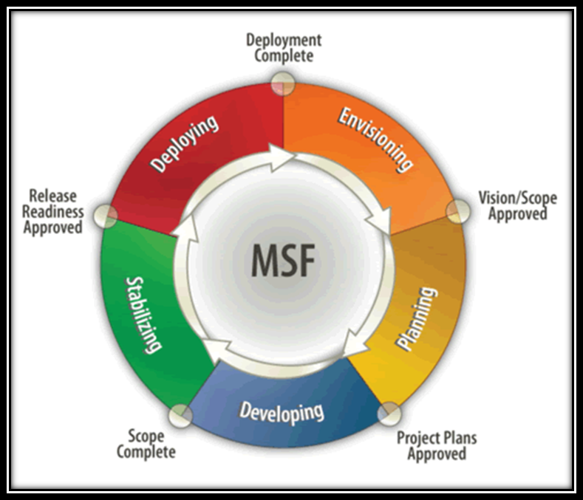

Adopted Methodology: -

As per requirement, we will adopt the “VU process model”. The description of which is given as under

VU Process Model: -

This model is the combination of waterfall and spiral methodologies. It is also called hybrid approach. It has following phases
- gathering and analyzing requirement,
- planning
- analysis and design
- development
- final report
In the first phase the system goals, services and constrains are marked after discussion with client. The planning phase is synchronized after making effort to find all the potential roadblocks and draft a robust plan to tackle these. This phase usually involves a lot of effort within software development team as well as with respective client. It maximizes the quality of system and reduces errors and risk.

Reason to choose the VU process model

Our project is divided already into different phases we will work in each phase in sequence and will send it to our project supervisor. He will suggest us about the improvement in every phase. We will improve that phase according to the suggestions. This process will be used due to the spiral nature of VU Process model. When the phase well be improved and accepted by our project Supervisor then we will advance towards next phase. This will be done due to the waterfall nature of the VU Process model. Hence both models will be implemented in single form and that will be our VU process model. It will be error free as each step will be done in a sequence.

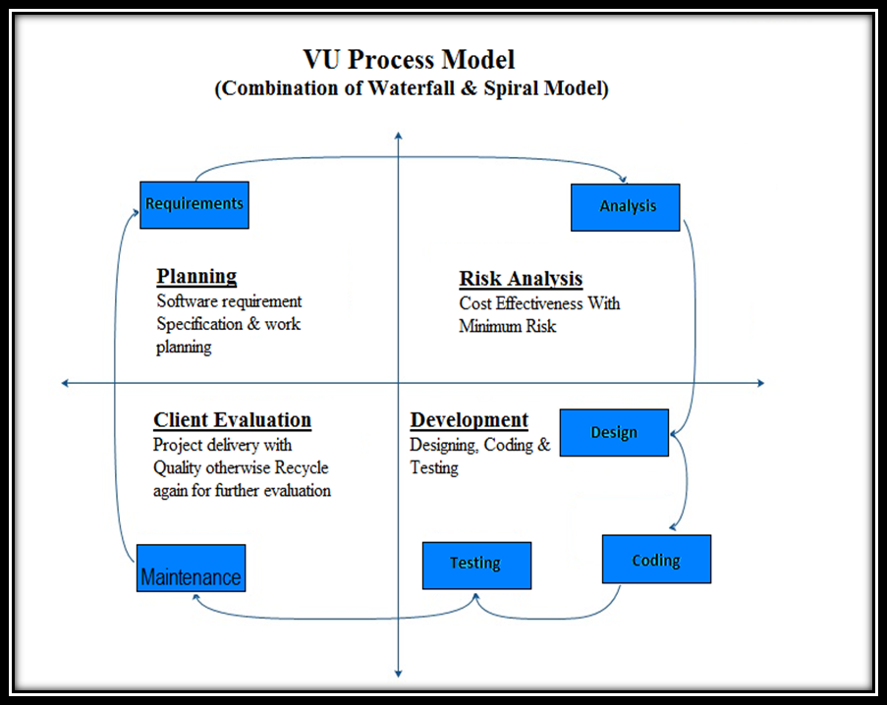

Work Plan (Use MS Project to create Schedule/Work Plan)

SRS AND DESIGN DOCUMENT
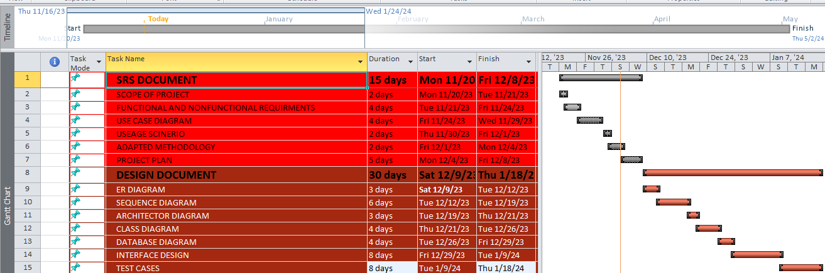

TESTPHASE AND FINAL DELIVERABLES

